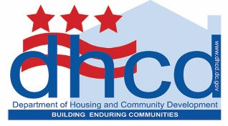
Department of Housing and Community Development
1800 Martin Luther King Jr. Avenue, SE I Washington, DC 20020
202-442-7200 I www.dhcd.dc.gov
The certification MUST be signed by the Owner or General Partner of record for tax purposes

This certification is for the annual period beginning January 1, 2020 through December 31, 2020.

Name: Click or tap here to enter text.(Insert Owner – GP Name)
Title: Click or tap here to enter text. (Insert Title)

Signature: _________________________________________ Date: Click or tap to enter a date.
(Owner)

Signed, sealed and delivered on the ________ day of ___________________, 20 Click or tap here to enter text. In the presence of: Click or tap here to enter text.

Warning: Section 1001 of Title 18 of the U.S. Code makes it a criminal offense to willfully falsify a material fact or make a false statement in any matter within the jurisdiction of a federal agency.

This certification and any attachments are made under penalty of perjury. Failure to complete this form in its entirety will result in noncompliance with program regulations. In addition, any individual other than an owner or general partner of the project is not permitted to sign this form, unless permitted by the state agency, the District of Columbia Department of Housing & Community Development (DHCD).

