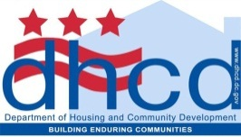
FREQUENTLY ASKED QUESTIONS
Spring FY 2013 Super NOFA REQUEST FOR PROPOSALS and APPLICATIONS

1. Can you clarify, for applicants seeking the DHS supportive services funding, is there a separate written submission required that somehow tracks the standards DHS outlines in its material? If so, then is there any particular format for the write up?
ANS: As a matter of course, no, it is not a requirement to submit separate submission tracking DHS standard outlines, however, should you determine your application requires a separate written submission to clarify or illuminate a particular theme or part of your application, please feel free to prepare and use the format that best fits your write up.

2. Similarly, is there any write up required to request the LRSP operating subsidy funds, or is the main NOFA application sufficient?
ANS: The main NOFA application is sufficient, improvise as required.

3. FYI, the DHCD website has often been inaccessible for users looking for the NOFA materials.

ANS: Thanks for the heads up, we will notify our IT staff that our website from time to time is not accessible.

