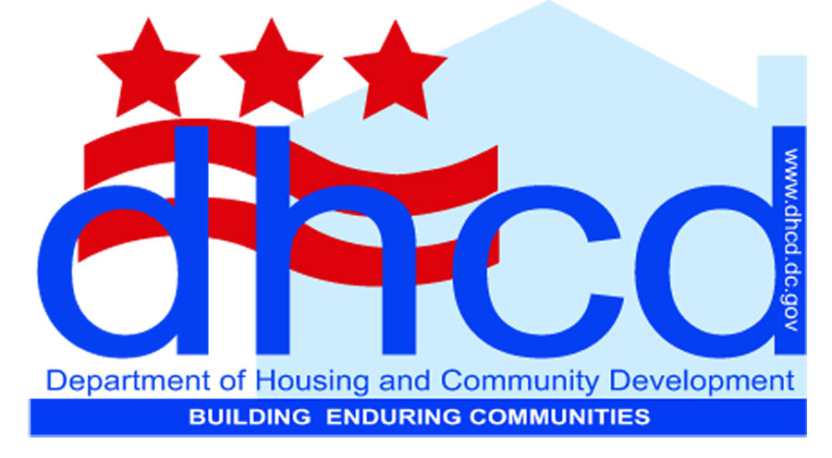
Relocation and Displacement Information
Department of Housing and Community Development
FACT SHEET

The Uniform Relocation Assistance and Real Property Acquisition Policies Act of 1970, as amended (URA – 49 CFR Part 24) applies to the displacement of tenants that results from acquisition, demolition, or rehabilitation for HUD-assisted projects carried out by public agencies, nonprofit organizations, private developers and others. The URA protects all persons who are displaced by a federally assisted project regardless of their income.

What are URA objectives?
- To provide uniform, fair and equitable treatment of persons whose real property is acquired or who are displaced in connection with federally-funded projects.
- To ensure relocation assistance is provided to displaced persons to lessen the emotional and financial impact of displacement.
- To ensure that no individual or family is displaced unless decent, safe, and sanitary housing is available within the displaced person’s financial means.
- To improve the housing conditions of displaced persons in substandard housing.
- To encourage and expedite acquisition by agreement and without coercion.

What projects must comply with URA?
If any project requesting federal funds will result in displacement, then the displacing agency (i.e., owners, developers or property management agencies) must comply fully with all requirements of URA.

Low Income Housing Tax Credits (LIHTC) and Housing Production Trust Fund (HPTF) are not considered federal financial assistance under URA. Applying for these funds alone will make your project exempt from URA, but if you are planning to apply for “layered” funding, federal funds offer “blanket URA coverage” for the whole project, even though it may be the LIHTC/HPTF portion that is displacing the tenant.

Planning is critical. Relocation and Displacement concerns must be thought about early in the process so decisions about rents, construction timing, and project feasibility can be considered before they are a crisis. It must also be noted that DHCD strongly discourages proposals that will result in permanent displacement activities.

Contact: Patricia Godwin, Relocation Specialist - 202.442.7246
Updated 1/10/13
Department of Housing and Community Development
1800 Martin Luther King Jr. Ave. SE  Washington, DC 20020
(202) 442-7200  www.dhcd.dc.gov
Vincent C. Gray, Mayor
Michael P. Kelly, Director

